Chapter 2, Problem 68.

- Find the current i in the circuit of Fig. 2.128(a).
- An ammeter with an internal resistance of 1 Ω is inserted in the network to measure i' as shown in Fig. 2.128 (b). What is i"?
- Calculate the percent error introduced by the meter as
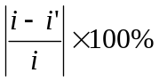
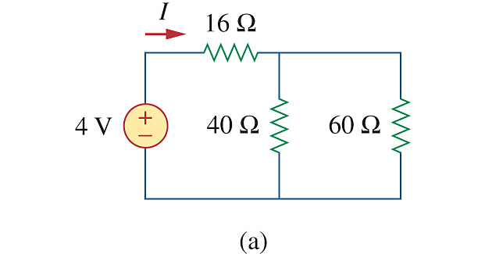

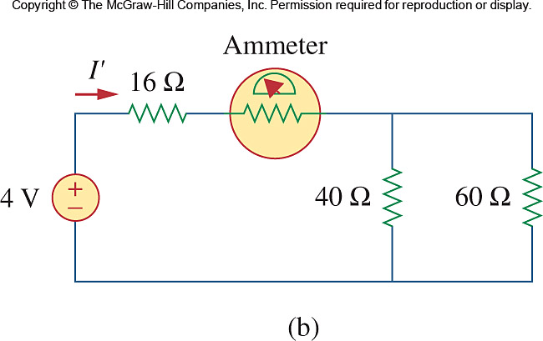

Figure 2.128
For Prob. 2.68.

